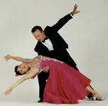
Dancing Or Just Standing There

by Harold & Meredith Sears

Most of our dancing progresses. We move down the line of dance. The hall is a whirling, swirling cloud of grace and beauty. But sometimes, even in the smooth rhythms, like waltz and foxtrot, we encounter choreography that does not progress. When faced with such figures, the question arises—are we going to keep dancing, or are we just going to stand there?

PROMENADE SWAY—

The Promenade Sway might be one of the most common examples of what we are thinking about here. It's not an easy, nothing figure. It's rated phase IV. It often uses a full measure of music. Again, what are we going to do during that measure, dance or just stand there?

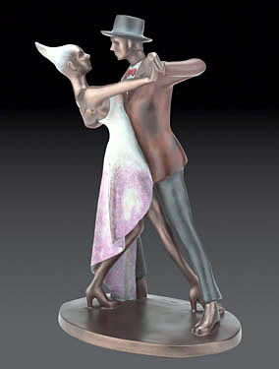
Look at the figure name. "Promenade" means semi-closed position and "sway" means inclination of the body, in this case to the man's left. So a Promenade Sway is a left sway in semi-closed position. Let's suppose we are in closed position, facing the wall, with lead feet free. The man steps side and forward L (woman sd & fwd R), blending to semi-closed position. He stretches the right side (woman left). You look up and over your extended lead wrist. "Look at your watch," one of our teachers used to say (if you wear a wristwatch on that arm). During the second "slow" count, relax your lead knee just a bit and so emphasize the right-side stretch (woman, left-side). Keep your unweighted legs straight and strong. In any "line" or picture figure, you should have one soft knee (the weighted leg) and one straight leg (the unweighted)—never two bent or two straight. The unweighted heel may be just a little off the floor. There is only one weight change.

One thing that you can do to make this figure smoother is to be sure to get your lead foot in position before you put your body out there. Point the foot, place it, then push off with the trail foot and move the body over the lead foot. If your body gets there before or even at the same time as the foot, the action could end with a jerk or a plop. Another little refinement is to angle your foot a little as you take the step. If you step straight forward, in line with your body, you may feel a little as though you are standing on a rail with a tendency to tip left or right. If you angle your lead foot, you will have a broader base on which to stand.

Now, did we just take a step and stand there, or did we dance? The key to dancing is to stay in continuous, fluid motion—never stop. (You know we're not talking about tango, here, right? Let's be sure we're still doing a waltz or foxtrot.) So in the Promenade Sway, we moved our lead feet, our bodies, we took weight, softened the lead knees, and initiated left sway. We spread all this over the whole measure. We "milked" every bit of the available music and then continued into the next figure. We never stopped. We didn't just stand there.

CHANGE OF SWAY—

Now, the next figure might not progress either. Let's suppose the next cue is "change the sway." All this means is to lose whatever sway you have and initiate sway in the other direction. Our Promenade Sway was to the left, so we relax the right-side stretch, being careful not to collapse or "break" that right side and then begin to stretch the left side (woman right). Keep your hips well into your partner, especially the man's right hip. This will turn her the slightest bit to the left, and it will keep your shoulders back and off your partner. The left-side stretch and the little left rotation will close your bodies and close her head. Your top-lines are apart, you are looking over your partner, she is looking well to her left.

There was no step, no change of weight, but there was a lot to do, and we smoothly spread those movements over the whole measure. We danced the figure.

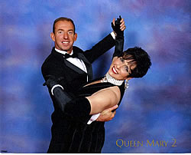
OVERSWAY—

Where the Promenade Sway is a left sway in promenade position (semi-closed), the Oversway is a right sway in closed position, and the "over" in the name implies that we use a little "extra" right sway. Perhaps we have just danced our Promenade Sway, and the cue is change to an Oversway.

Again, the man relaxes his right-side stretch, which brings him out of his left sway to a more upright position, and then begins to stretch the left side (woman right). He lowers a little more into his left knee, rotates his hips LF, turning the woman to closed position. She will actually rotate about 1/4 on the ball of her right foot (ladies, don't put any weight on that heel or you won't easily turn). We are doing a little more than a simple change of sway. Keep your shoulders up and level. Push your right hip into your woman; don't hunch your shoulders over her. Your top-lines are well apart, your shoulders parallel. Your lead knees are soft, but your trailing legs are straight and strong. Look up and over your partner. Rotating while lowering is important in leading the woman to leave her trail foot extended and pointed to reverse.

Sometimes, the ending of a dance will be cued simply, "Oversway." What you will do will probably depend on how much music remains. If this piece seems to be ending with a long decrescendo, then you will probably want to dance the notes out with a full Promenade Sway and Oversway, slowly milking out every last bit. But if the piece ends with a bang, then you can abbreviate or eliminate the Promenade Sway part and step quite sharply into the "lower, rotate LF, and right sway" sequence. We have danced at least one routine that ended with the cue, "Oversway and change the sway." If you have enough music, you can do that, but an Oversway takes time to do—it includes a little "extra," remember—and changing sway gracefully (back to Promenade Sway in this case) takes time, too. We suspect that most dancers would dance the Promenade Sway to Oversway, rather than the reverse, no matter what the cue. The important thing is to keep your bodies moving in a steady, graceful flow; to really dance the figures, and not just stand there.

THROWAWAY OVERSWAY—

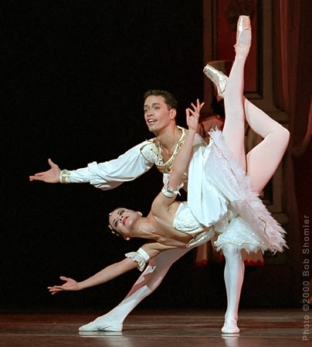
Of course, the Throwaway Oversway is very similar to the Oversway. The key difference for the man is a delay in the lowering of the bodies. The man rises out of his Promenade Sway. He might swivel just a little on the ball of his left foot—he would like his left toe to point just where he wants her to "throw" her left foot. He changes to right sway and rotates the hips left-face to move the woman's left leg back, and then lowers by flexing the left knee so that she won't take weight on that foot but will continue to move it back behind her, exposing the sole of the foot to passersby. The man's motion is a little like "bowling her foot down the alley." It is a little more elegant for her to slide her foot back with the inside of the big toe touching the floor, rather than the tip of that toe. Look at your partner lovingly.

Again, many of the features of the Throwaway are the same as those of the Oversway. We have the change of sway to the right, the left rotation, and the lowering. But we rise strongly to lead the woman to collect her left foot, and as soon as she had done so, we lower to lead the foot to slide back. In the Oversway, we rotated in a lowered position so her left leg stayed where it was. In the Throwaway, we rotate in a raised position and then lower to send it back.

HINGE—

From a Promenade Sway, the cue could also be, rise to a Hinge. A Hinge is a same-foot figure, so we will have to include a transition. The man rises, straightening the left knee, initiates left-side stretch without collapsing the right side, fills his lungs, lifting the woman, and so draws the trail feet in toward the lead feet. In this "up" position, he rotates his hips LF, leading the woman to collect her trail foot and to change weight. The right sway and LF rotation should put her left foot behind her right. His left and her right hips are tight together, and her left hip is in as well as is comfortable. Flex left knee to lower and cause her right foot to slide forward, leg straight. End in somewhat of an L-position with man's left knee flexed and his right leg straight and extended to his right side, and woman's left knee flexed and her right leg straight and extended in front of her, parallel with his. She is almost sitting on his left thigh with her head left. In most of our dancing, we do not look at our partners, so as not to invade their space, but here I think, you may gaze into her eyes.

Have you noticed that a key difference in the leads for the Oversway, Throwaway Oversway, and Hinge lies in the timing of the man's left rotation and his lowering?
- If he rotates in a lowered position or while he is lowering, he leads an Oversway.
- If he rotates first and then lowers, he leads a Throwaway.
- If he rotates first, waits a moment for her to change weight, and then lowers, he leads a Hinge.

RIGHT LUNGE—

Could we dance a Promenade Sway and rise to a Right Lunge? At the simplest level, we might simply step side onto our trail feet, but again, there is more that we can do to really dance the figure. We can rise on our lead feet, relax the right-side stretch (woman left-side), and blend to closed position. That's half a measure. Then we begin to lower again and at the same time reach out with the right foot side and slightly forward between her feet with a little right-shoulder lead, change weight, sway right, rotate just a little left-face, and look right (woman left). Again, your hips are in toward each other, your shoulders are level and apart. We needed the whole measure to fit all that in—we couldn't just take a step and then wait.

SAME FOOT LUNGE—

Where the Hinge has the right legs for both extended on a strong diagonal, the Same Foot Lunge has the left legs extended into a pretty picture figure.

From a Promenade Sway, we again rise, straighten, and blend to closed position. Since this is again a "same foot" figure, we have to do a transition. Often, the cue is "prep for a same foot lunge." The "prep" is a slight rise and right face rotation causing the woman to rise to her toes and change weight to her left foot. She has rotated a little RF but not as far as to semi-closed position—you are still closed, and both now have right feet free. Now we can do the figure.

Lower in the left leg and step side and slightly forward R with right-side stretch and looking right (woman steps back R turning LF and looking well left). The man's left leg will be extended to the side, straight and strong. The woman's left leg will be crossed in front of her right and extended on the same diagonal as the man's. Keep your hips well in to your partner. Again, you are in closed position (not an L-position).

In all of these two-measure sequences, we remained in one place. We took only one or two steps, but we never just stood there, waiting for the dancing to begin again. We were dancing the whole time.

