The Healthy Side of Round Dancing

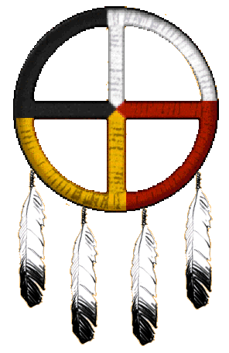
by Harold & Meredith Sears

You might be thinking that you are round dancing just for fun. "Smile," they say, "this is your recreation!" But you are dancing for your health, too. Round dancing is a perfect activity for improving physical, mental, emotional, social, and even artistic or creative health. We’re not just fooling around.

Physical Health—

Many people realize that they are dancing "for fun and for the exercise." They know that dancing is good for us. A waltz might flow along at 30 or more measures per minute. That’s about 100 weight changes per minute. We don’t walk or run or lift weights that fast. Dancing burns anywhere from 200 to over 2000 calories during a 30-minute period—as many as walking, swimming, or bicycling.

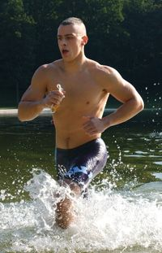
Like some other forms of exercise, dancing is "whole-body." Of course, you are working your feet, ankles, legs, and hips, and you work different muscle groups when you dance backwards than when you go forward. But think too of what the maintenance of good posture and proper frame does for you—staying balanced, the use of body sway, counter sway, and contra-body position. The shoulder and arm muscles keep the arms up and in proper position. The abdominal and lateral muscles produce stretch and sway. The back muscles form good posture and body frame. There is probably no muscle in the body (and there are over 600 of them) that doesn't contribute its share to maintaining tone and smoothing and controlling the flow of the body around the ballroom floor.

At first thought, you might guess that a fast jive or mambo would give you the best dance workout, but we work as hard in a slow waltz, with its picture figures, in which you hold your position and slowly move through a change of sway and then maybe into another picture, with every part of your body under toned control. In this part of the waltz, you may not be progressing at all. There are no running steps, no locks, skips, or hops. But every muscle is working hard, none-the-less.
Not only are we working the muscles of our bodies, but we are exercising the bones to which those muscles are attached. In the partnership between our bones and muscles, the bones rarely get the recognition that they deserve. If we ever consider how we did that forward waltz, we would easily give credit to various muscle groups, but without the associated bones, we would have gone nowhere. The body moves when muscles pull on bones. The muscles can't do it themselves, and the bones need that exercise. They are not dead sticks but are active, living organs in their own right, and exercise improves bone strength, tendon strength, and the tendon-bone connection.

While we're at it, let's recognize that we are strengthening the cardiovascular system that supplies oxygen, fuel, and other nutrients to our muscles and bones. Our body is designed to respond to use. "Use it or loose it.” So our heart becomes stronger, the arteries and veins more resilient. The heart rate slows, blood pressure goes down, and cholesterol levels drop. In a study of 110 heart-failure patients, recently presented at an American Heart Association meeting, the slow waltz was shown to be just as effective at improving cardiovascular function as a treadmill or bicycle. Improved circulation gives a glow to the skin. Movement is good for the digestion. There’s probably no part of the physical body that doesn’t benefit.

Motivation—

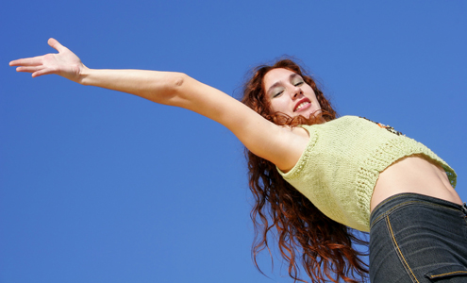
One of the fundamental principles of any good exercise program says that you'll do better with a buddy. If you say to John or Jane that you will meet him or her at the pool at seven, then you will do it. If you slack off and skip it, John will know. Jane is depending on you. She doesn't want to swim alone. You have a commitment. What do you have if your habit is to exercise alone? There is self-motivation, but not nearly as much.

Now, what motivation does the dancer have? Your partner definitely needs you. Your friends are looking forward to your being there. Your teacher needs you and wants you to learn. Once you get to the hall, even the music is telling you to get up and dance. "The music tells you what to do." I don’t know how much it tells us about what steps to take, but it does tell us to get up and move.

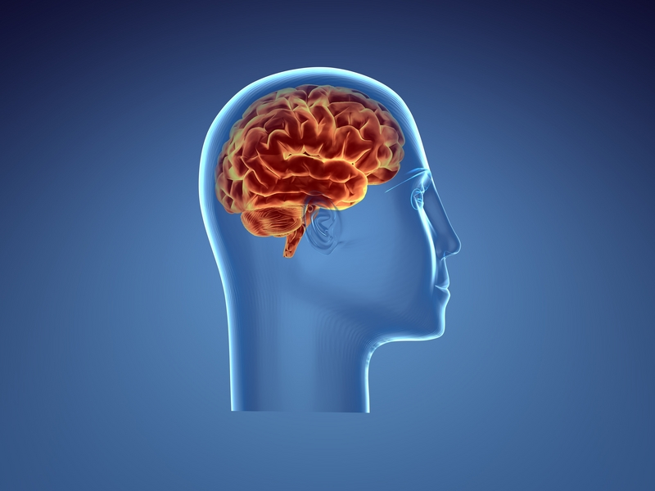
Mental Health —

Lately, we are hearing more and more that the very best form of exercise for the brain is dancing. It is the brain that coordinates the activity. Exercise increases blood flow to the brain so it can feed and breathe. Carla Morris recently wrote in American Dancer (Nov.–Dec., 2006):

A study printed in the 2003 New England Journal of Medicine involved observing 469 men and women who were at least 75 years old and were studied for an average of 5.1 years each. The researchers … wanted to determine whether physical activity played a part in the onset of dementia, or if mental activity was an important factor.

They monitored cognitive activities such as reading, crossword puzzles, learning to play a musical instrument, as well as physical activities such as housework and different forms of exercise. The group found that overall those who were mentally active were 75 percent less likely to develop dementia. Though physical activity had less of an impact, the most effective activity was ballroom dancing, which lowered the risk by 76 percent…

Think of all that coordinated muscular activity, precise movements in specific sequences, finely meshed lead and follow, all this matched to one piece of music after another. Does this happen by itself? No, the brain and entire nervous system directs it in great waves of mental activity. How many different figures have we learned — and figure combinations, and dreaded modifications? Probably just as many as crossword puzzle clues or bridge hands. And we have to think fast. The cue comes, and we don't have the luxury of thinking it over and maybe looking it up in a manual. We have to process those hundreds of cues, one after the other. We coordinate with the music and at the same time with our partner. This is heavy-duty mental exercise.
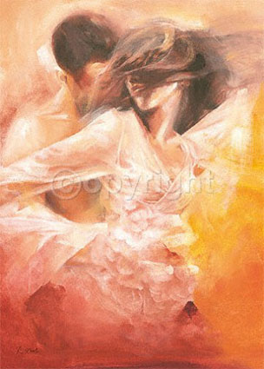

Emotional Health—

Round dancing is emotionally and psychologically healthy. Modern society is hectic. The details differ for each individual, and we occasionally find one or two people who seem to skip along the sidewalks of life with nothing but smiles and joy. But most of us encounter tense times. Our working life is frantic, meals are rushed, our homes are cluttered, our calendar is full … If any evidence is needed that these are widespread problems, just look at the best-selling books and big-circulation magazines that promise to simplify, unclutter, and help you find peace.

So, let’s go dancing. The moment the music starts, cares melt away. At home, you might use the same music to carry you away from the troubles of the moment or as background for chores and other activities, but on the dance floor, there are no chores or deadlines. Instead, we are with agreeable companions, in a happy, relaxed environment. We get to move in graceful ways. Our minds are swept clean of all those fussy little dust bunnies that have built up during the week. A dance is a mini-vacation at a streamside resort spa.

Where life is a hectic web-work of activities and responsibilities pulling in all directions, dancing is a smooth, linear flow. Where life can hunch you over, pull you in, and cast your gaze to the ground, dancing expands your body, stretches you up, and directs your eyes up and out. Where life is full of surprises and unexpected demands, emergencies to cope with, and fires to put out, dancing is pleasant and predictable. We have danced this dance before; at least we have danced these figures before. As we enter the hall, we leave our daily stress, impatience, and anxieties outside. We become our secret alter egos (Fred Astaire? Ginger Rogers?) and immerse ourselves in the peace of the dance. Even a challenging dance takes us away from our troubles and leaves us refreshed.

Social Health—
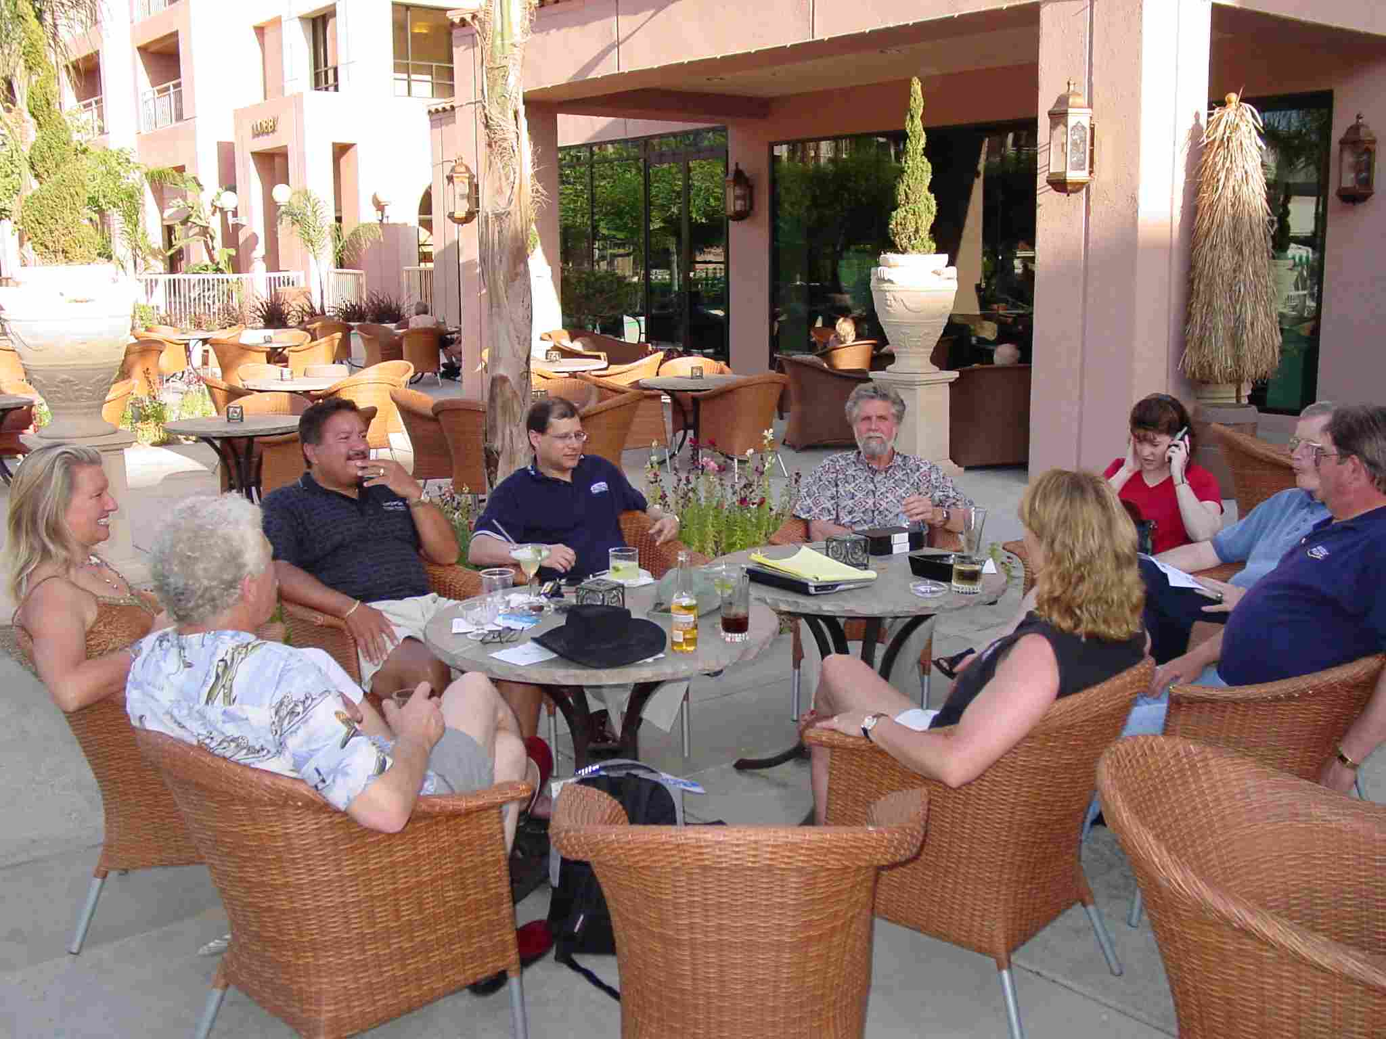
We are probably still thinking about forms of emotional health, but humans are social creatures. No one likes to feel lonely. To meet our social needs, we create all sorts of reasons and excuses to get together. We want friends, closer friends, regular contact, affirmation and encouragement. Surely dancing does these things better than most activities.

Dancers are open, friendly, non-judgmental, and forgiving people. Conversation is not likely to be dominated by lectures, sermons, harangues, or grouses. It will be light and interesting, fun and optimistic. Dancing is playful and flirtatious. When you get together to play cards, you have that card table between you, but dancing can be quite intimate. Other games are competitive; dancing is cooperative.

Artistic Health—

Finally, round dancing helps us to develop artistic or creative health. Dancing is an art form, but instead of paint and canvas, the dancers’ medium is their own bodies. Dancers are not just walking around the room in time to the music. We are rising and falling, swaying and changing sway, opening our heads and bodies and closing them. We call them "picture figures" for a reason. We are continuously creating these ephemeral works of art as we progress through each dance.
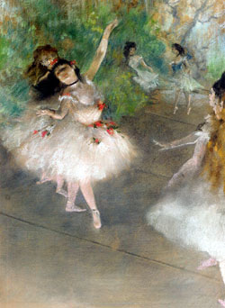
Humans seem to have an inborn need to create. Certainly, we have been doing it ever since the time of those old cave paintings and probably before. So express yourself in your dance. Let your artistic side out a little. You might feel that it is not really your place to give way to artistic expression. After all, you are not really Mikhail Baryshnikov or Martha Graham, Fred or Ginger. You might fear that you would make a spectacle of yourself. But you won’t. Look at dancers who look "good" to you. Is it because they know the figures or the routine better than others do, or is it because they are including some artistic expression?

So, let's not take our round dancing for granted. It is wonderfully good for us. It strengthens and heals our physical, mental, emotional, social, and our artistic selves. And of course, it’s fun, too.

