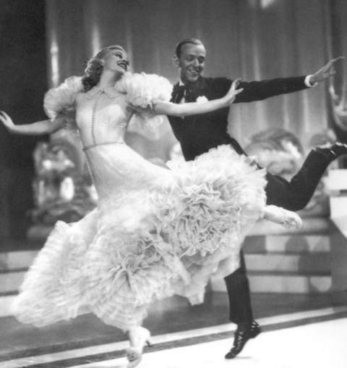
Make It Look Easy
by Harold & Meredith Sears

When Fred and Ginger made their movies back in the 1930s, they practiced each routine for weeks — even months. By the time they got it on film, it looked so easy and natural that you could believe they were making it up in the moment. They flowed across the floor so comfortably that it seemed like the most casual of conversations between friends. They had worked out absolutely every detail ahead of time, so they didn't have to struggle with them during the dance.

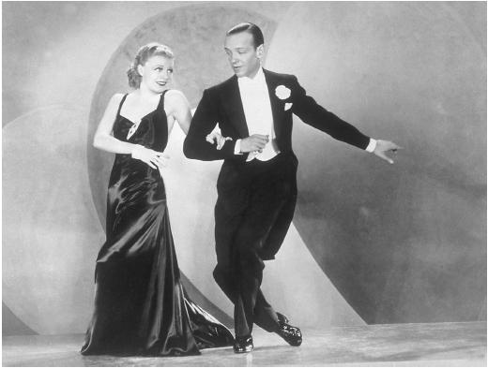
Now, we are not doing a performance, and we are not going to work on one dance for months, but isn't this how we'd like our dancing to feel? We don't want a rough struggle. We want easy sailing. And the secret is in the details. For each figure, there is a comfortable way to do it and probably dozens of uncomfortable ways to get through it. If we only think of the figure in a general way and sort of blast through it, we'll probably happen on one of those uncomfortable ways. But if we can devote a little effort — not months, but a little — to the component steps and movements, then we can find that comfortable way to dance it.

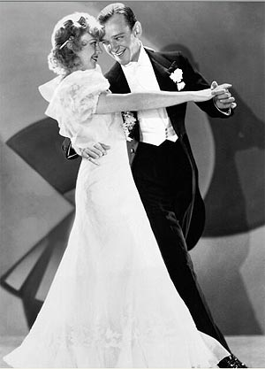
So, our tip is to pay attention to how your teachers present a figure and to how they dance it — not just to the the big picture but to the details, too. And experiment with your partner. Reach a little farther. Try some shoulder lead or sway. Trial and error is an unsophisticated form of learning, but it often does the job.
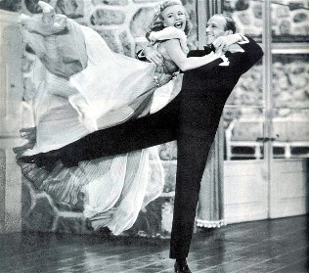
One example — let's think about the Reverse Turn in foxtrot. We just turn left in three steps and then again in three more, right? But look a little closer. Does your lady get to do a comfortable heel turn, or does she have to force it to happen? At the end of the first measure, are you in closed position and connected, or have you separated to a tugging kind of banjo? The difference between a smooth Reverse Turn and one that feels like work is in just a few details.

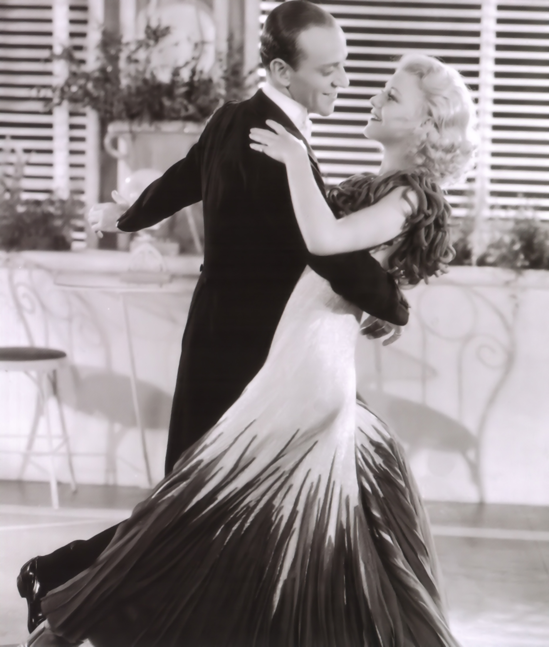
In closed position, facing line and center, the man steps forward left straight down that diagonal, and the lady steps back right. The first step is not a turning step, but we do need to use upper-body rotation or right-shoulder lead. The man's feet are pointing line and center, but his upper body is facing center or even a little to reverse. This is the first detail that will keep you in closed position and help her to do an easy heel turn.

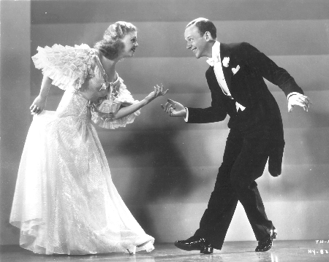
The second key is to make the next step forward and side right, stepping on the same diagonal line and stepping through the lady's left hip, turning her. The lady simply draws her left foot to her right. She is being turned on her right foot (the heel turn), and as she feels the man take weight on his right, she shifts her weight to her left, ready for the third step. The common error is for the man to get off the diagonal, to dance more down line, and to think that he has to dance "around" his lady. If you do this, she will be led to progress, will not be able to do the heel turn, and you will end in banjo at the end of the first measure. So, take steps 1 and 2 toward line and center, turning your body as you move through her left side; dance a straight line, not a curved path around her. Her heel turn will just "happen," and you'll be in good closed position for the third step, straight back left for the man and forward right for the lady, now moving down line.

Sometimes, our first reaction to these kinds of details is that they are "picky." But they surely add to our comfort and fun.

