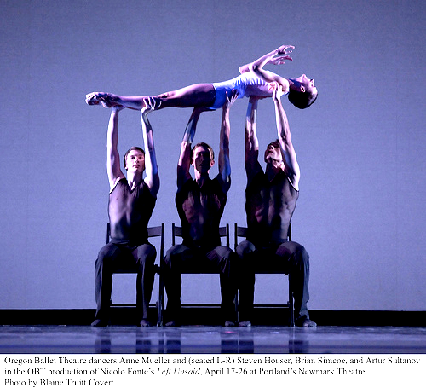
Harold and Meredith Sears

Waltz Chair

Just kidding….

We dance this figure in semi-closed position, maybe facing line of dance with our trail feet free. We simply step thru with a slight lunging action and soft knees. The curve of that trail leg should suggest the leg of a Queen Anne chair (see below). A little more simply, we might imagine our thighs to be the seat and our torsos to be the back of any ordinary chair.

Sometimes, choreographers want to specify the poise of the upper body during a Chair. The usual or default Chair is a Forward Poise Chair, looking forward and with the torso inclined a bit forward. In a Back Poise Chair, you step thru with the trail foot and at the same time look back, over your right (lady's left) shoulder, with a little sway to reverse. For example, in the Shibatas' Edelweiss, there is an impetus to semi; back poise chair recover point to reverse; forward poise chair recover slip; double reverse spin;

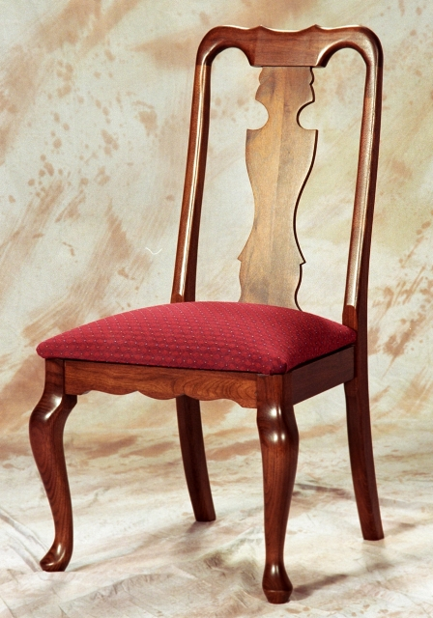

A Step is a movement of the foot from
here to there. A Figure is a specific sequence
of steps forming a set that is complete, is often
standardized, and is widely accepted and used
as one component of a dance routine.

