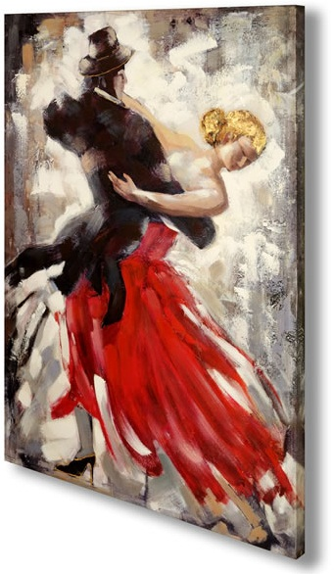
Paso Doble Appel
by Harold & Meredith Sears

The standard Appel is a one-step figure that often serves as the first step of a one-measure or longer figure. It is danced in loose closed position and standing high on the balls of the feet. We lower sharply onto the trail foot (Q). You may also execute a back flick of the trail foot, on an initial &-count, before lowering (&Q). The purpose of the Appel is quietly to call the attention of the woman and to initiate the lead into whatever figure is to come. So, you might Appel and at the same time initiate the forward body movement into an Ecart (the paso Whisk). Or you might Appel and at the same time blend to semi-closed position for a Sixteen. The Appel is not only a close R (W close L). It is also a lead -- a blending into the position or movement that follows.

A Flamenco Appel is a soft stamp and so allows you to make a little noise, and the Stamp Appel is a more aggressive flamenco move, a stamping of the trail foot, that makes as much noise as you care to make. Watch some flamenco dancing on YouTube. You might see a dancer in high, hard heels on a resonant stage taking quiet steps and even quiet prancing steps, but punctuated here by a soft "tap-tap" and there by a louder machine-gun burst. (In fencing, the Appel is a stamping noise used to distract one's opponent.) In the bull ring, a Stamp Appel would raise the dust and put the bull on notice that we are serious.

An Aside: Most cue sheets simply call for an Appel. Does that mean that you shouldn't make noise? Well, it might simply reflect the fact that only the Appel is a Roundalab Standard (phase IV). This is what the manual offers, so this is what choreographers write. But, we know about the bull-fight origins of paso doble. We know of the flamenco influences. If you want to make a statement, if you want to excite the bull, then maybe you should do it. We were teasing a friend recently about his lone Stamp Appels on a floor of dignified standard Appels, and his response was to dance the Appel but to add instead a spirited olé. Styling is always optional, and round dancing is supposed to be fun.

A couple more variants -- The Double Appel, of course, is an Appel twice, quickly (&Q), leaving the same foot free as before. The purpose is more an individual display than a lead, and it may involve a double stamping noise. We first encountered this figure in Vamos Amigos by the Shibatas. Here, we are in a sidecar left-foot Spanish Line, M facing RLOD. We wheel forward to a Double Appel (QQQ&Q); wheel back to a Double Appel (L feet free); and wheel 8 left full turn M Double Appel (a transition) to face partner and wall (trail feet free).
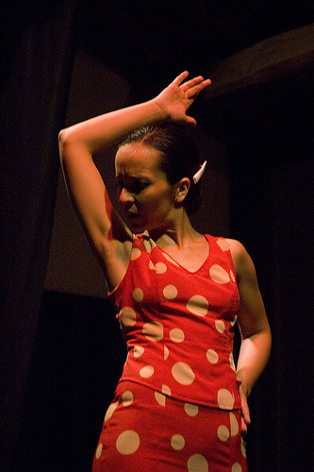
Finally, in the Slip Appel, we step slightly back R (W fwd L) lowering and turning 1/8 LF to CP. This step is used as a strong lead into a variety of left-turning figures. We might Slip Appel to an Open Telemark or to a Reverse Fallaway. The Slip Appel offers some initial punctuation or perhaps the capital letter at the beginning of a sentence, and the figure proper begins with the lead foot, as in our more familiar rhythms.

