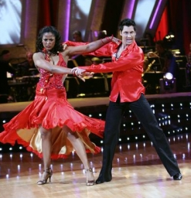
One Figure —

Paso Doble Chasse Cape
by Harold & Meredith Sears

The standard figure is eight measures and 32 steps. The name tells us that it contains chasse "triples" and "caping" movements for the woman from one side of the man to the other.
In loose closed position facing the wall, we appel R (woman L), step side L turning to semi-closed position facing line of dance, thru R (W thru L) both turning right-face, side & back L (W forward R) to closed position facing reverse.

In the second measure, step back R (W forward L) continuing to turn right, small back L leading partner outside (W forward R to banjo position) pivoting right-face and then forward R outside partner (W close L) continuing to turn to closed position facing wall. These two steps (L, R, for the man) can feel something like the beginning of an outside spin in waltz. On the fourth beat, we begin our first chasse with a side L/close R for the man (W opposite).
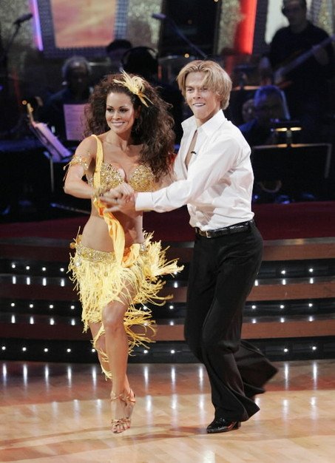
In the third measure, complete the chasse by stepping side & back L, then step back R turning a little more right-face to lead partner outside (W forward L to sidecar position) now pivoting left-face, forward L outside blending to closed position facing center. Again steps two and three feel a little like a reverse outside spin beginning with the man's right foot. On the fourth beat, again begin a chasse with a side R/close L for the man.

In the fourth measure, again complete the chasse by stepping side & back R, then step back L turning a little more left-face to lead partner outside (W forward R to banjo position) now pivoting right-face, forward R outside blending to closed position facing wall (outside spin–like), side L/close R.

In the fifth measure, complete the third chasse by stepping side & back L (W side & forward R), then step back R turning a little more right-face to lead partner outside (W forward L to sidecar position) pivoting left-face, forward L outside (W close R) continuing to turn to face diagonal line and center (reverse outside spin–like) and release hold with the right hand, side R (W side & forward L turning left-face) to left open position both facing line of dance.

In the sixth measure, there are no weight changes. Step forward L (W forward R) onto the ball of the lead foot turning the body a little right-face (W left-face) into a press line, and hold three more beats. The lead feet are still free.

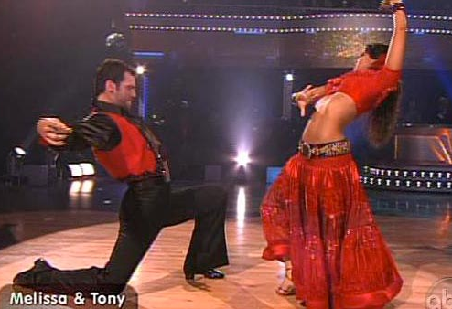
In the seventh measure, turn 1/4 left-face and close L (W 1/4 right-face and close R)/step R (W spin right-face on R under lead hands and close L facing wall), step L (W step R), side R, close L ending in closed position facing center.And in the last measure simply step side, close, side, close remaining in closed position facing center. The count for the whole figure is: 1234; 1234&; 1234&; 1234&; 1234; 1234; 1&234; 1234;Two additional comments: First, it helps if you do not think in terms of measures of music, at least through the first five measures. Instead, begin this figure with a count of five. These steps put you almost in banjo position facing reverse with lead feet free, and these five steps form a standard beginning to some other Paso figures (e.g., Sixteen, Promenade), so they are worth thinking about as a "unit." Now you can do your three "chasse caping actions" as individual units: step, step turn, and triple; step, step turn, and triple; step, step turn, and triple. Each of these sequences crosses a measure, but each certainly feels like a self-contained unit. Once you get into the press line, you are dancing on the measures again.
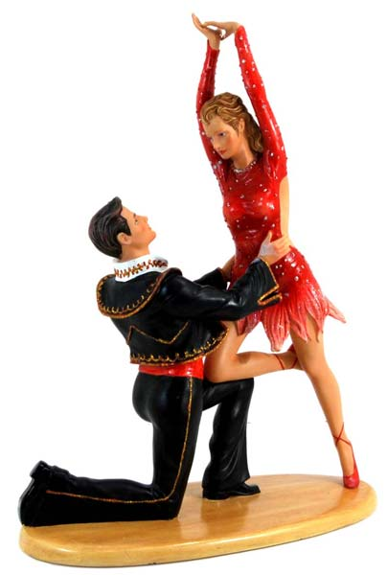
Second, we don't have a lot of experience, but I don't think we have ever danced this "standard" Chasse Cape. We usually overturn the "outside spins" so we are dancing the chasses on the diagonals (DRW & DRC). And we have only seen shortened versions of the figure so that it ends in the press line — and then the choreographers ask us to do something else. For instance, in Trumpet Fiesta by the Gosses, there is a six-measure Chasse Cape;;;;;; to Flamenco Taps. In El Conquistador, also by the Gosses, there is a four-measure Chasse Cape (only one chasse in this one) to a press line and arms;;;; Flamenco Taps & recover; and then appel to Traveling Spins.

A Step is a movement of the foot from here to there. A Figure is a specific sequence of steps forming a set that is complete, is often standardized, and is widely accepted and used as one component of a dance routine. This figure description was adapted from rounddancing.net/dance/figures/paso.html
